|  |  |
| --- | --- |
| cetlogo ***CHEMICAL ENGINEERING TRANSACTIONS***  ***VOL. 95, 2022*** | A publication of  aidiclogo_grande |
| The Italian Association  of Chemical Engineering  Online at www.cetjournal.it |
| Guest Editors: Selena Sironi, Laura Capelli  Copyright © 2022, AIDIC Servizi S.r.l. **ISBN** 978-88-95608-94-5; **ISSN** 2283-9216 | |

ON LINE MONITORING OF ODOR UNIT (OU) EMISSIONS AND ODOR SOURCES IDENTIFICATION, BY USING A NEW GENERATION OF GAS AND ODORS ANALYZERS (IOMS) FOR PULP & PAPER COMPANY

Authorsa, Jean-Christophe Mifsuda Ph.D, Fatma Ayounib, Benjamin Rolland Ph.D c

a ELLONA jean.christophe.mifsud@ellona.io

b ELLONA fatma.ayouni@ellona.io

c ELLONA

**Abstract**

Dynamic Olfactometry ( EN 13 725- ASTM 679) is the standard and well established technique for odor intensity measurements, however it is not always adapted for big industrials sites which need continuous monitoring and fast results to take the appropriate remediation action. Additionally, these sites need to have odor sources identification solutions to ensure proper remediation actions or to protect themselves from non-legitimate claims.

In Canada, a large Pulp & Paper company, was interested in better assessing on line gas and odors emissions of their operations, aiming at identifying the possible source and situation of possible olfactive nuisances on the neighbors.

The paper company is surrounded with communities living close by as well as a cookie and chemical factories that can also be source of olfactive nuisances.

The Company does not have the tools to quantify or to identify the sources of the olfactive pollution aside of regular round of the facilities by local personnel.

The expected outcomes of the study were:

1. Better understand the sources of olfactory nuisances.
2. Assess quantitatively the efforts to reduce odor intensity on site.
3. Reduce the number of complaints.
4. Reduce usage of biocides/ additives.
5. Save energy.
6. Differentiate themselves from near located emissions
7. Optimize processes (time of the day, weather, general pollution situation).
8. Optimize equipment maintenance.
9. Lay ground for better relations with stakeholders (community, authorities, neighbors).
10. A greener and more sustainable industrial operation in the area.
11. Extend lifespan of your total industrial operation in the area.

In the experiment with this paper Company, an array of WT1 devices was deployed on two different sites close to the dryer exhaust and the vacuum exhaust.

During the initial training period, an anomaly detection model was trained with data obtained at factory downtime,in order to correlate significant sensor variation with the claims from coworkers and neighbors .

Additionally, a linear classifier approach (Linear Discriminant Analysis) was used to differentiate between the different sources of odor and pollution.

ELLONA WT1 gas and odors sensing units allow for not only online monitoring of Odor intensity and various gas emissions, but also for odor fingerprint identification. This paper presents the technology and data processing methods for odor sources identification, effectively combining a range of smart sensors (IOMS) with statistical data processing techniques on the field

A network of WT1 monitoring device of gas and odors from ELLONA, including H2S, mercaptan, NH3, SO2, CO, and PID sensors were installed at different locations around the paper company at the source and at the fence line.

**The main objective was the Implementation of unified continuous odour monitoring system around the pulp and paper company and optimize the operation one line**

**Historical issues:**

* Dynamic air pollution sources;
* Emissions of smelling substances;
* Citizen complaints;

**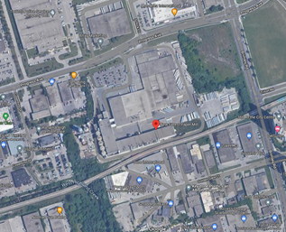**

* Fig one , picture of the site

Fig 2 visualization of the site and one WT1 monitoring station.

Fig 2 : The WT1 is a IOT cloud base gas, odor, liquid, noise, and particles analyzer that can encompass up to 12 different gas sensors of different technologies (PID, MOS, Electrochemical cells and NDIR) as well as particles optical sensors. In this particular studies, we did use, a H2S, Electrochemical sensors, a CO, and 4 MOS sensors

|  |  |
| --- | --- |
| Location 1: forced Draft Fans looking West | |
|  |  |
| Location 2: installation at the exhaust vaccum | |
|  |  |

Fig 3 visualization of the deployment of WT1 at the 2 locations

* **The projects did involve**
* 1 – Odor levels automatic identification in real-time with Development of the location specific Odor Baseline. We analyzed the VOC / Odor emission intensity first in the downtime operations and then during the operation

[H2S] ppm

ELLONA Odor Unit

Operation

Downtime

One can see that the variation of VOC is below 500 Ellona OU during the downtime and can reach 2000 during operations.

It was checked with a sensory panel of coworkers that there was not specific Paper odor during the downtime but there was also other odors characterized as cooked or cookies.

Characterization of Perceived odors

We set up a sensory panel with regular patrol to be able to qualitatively identify the type of smell with various specific QR code around the sites with a specific questionnaire

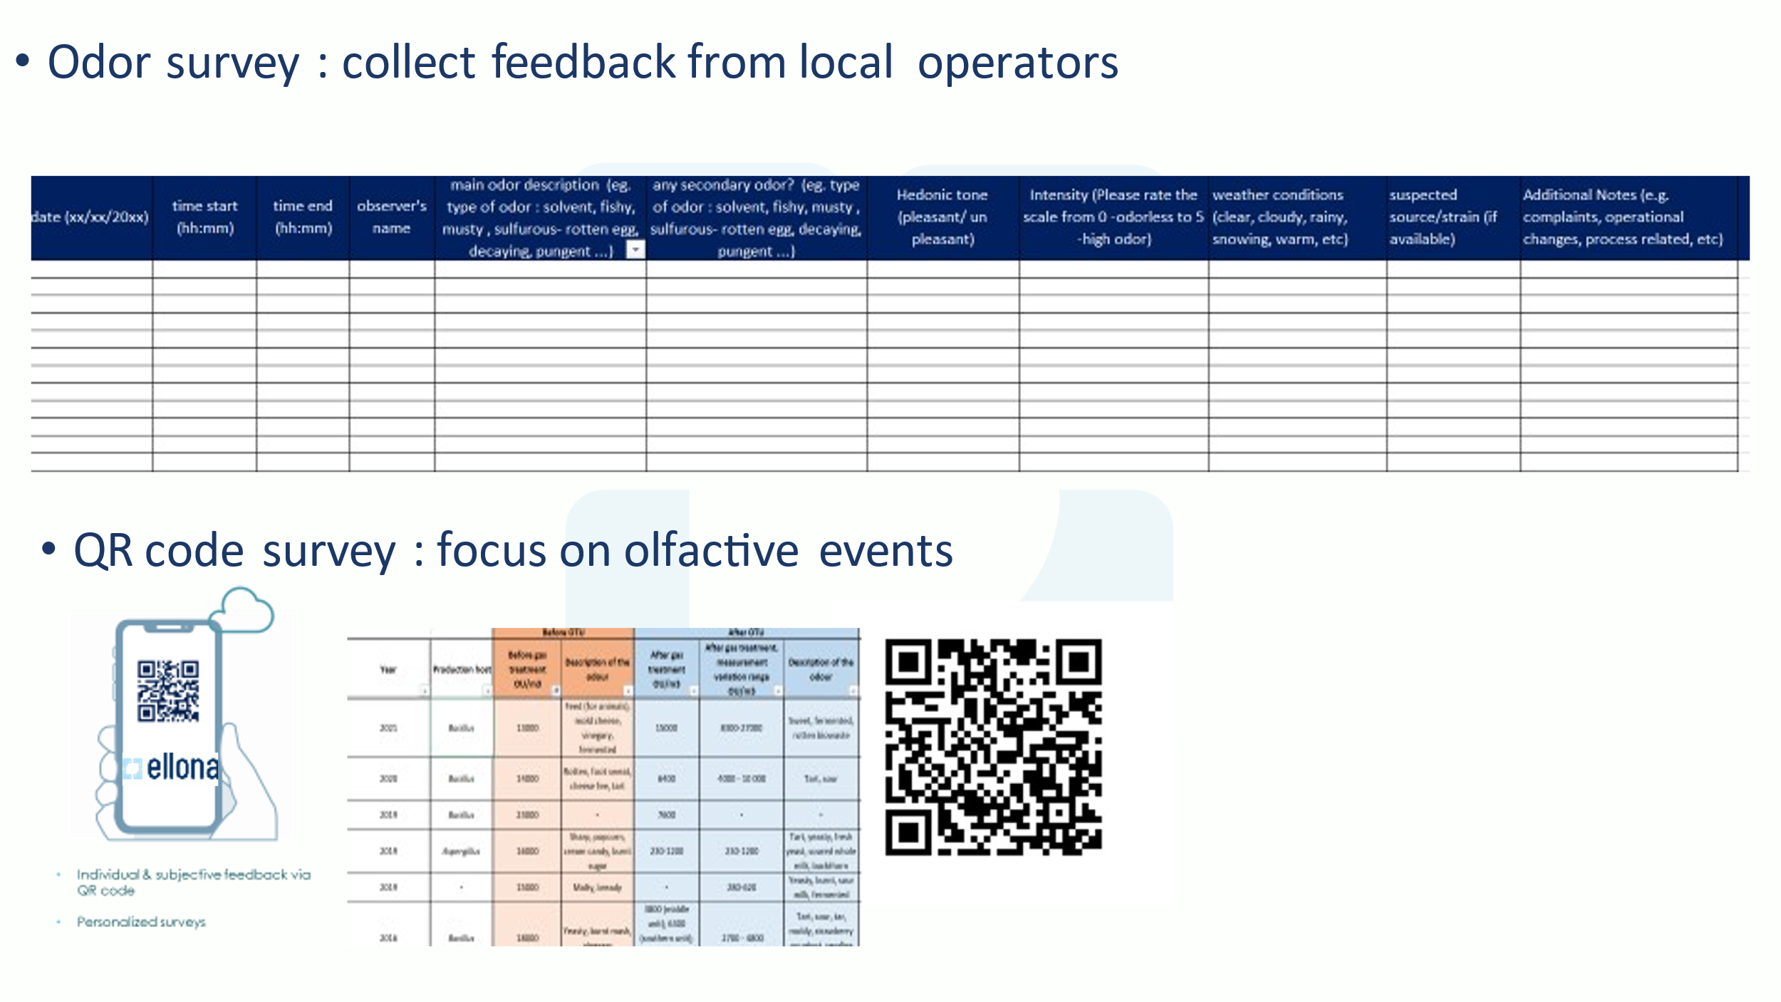

That did allows us to identify mostly 3 majors type of smells

-Classical paper smell

-Rotten Egg

-Pungent

On Fig 5, one case an example of the recording by the sensory panel of the events

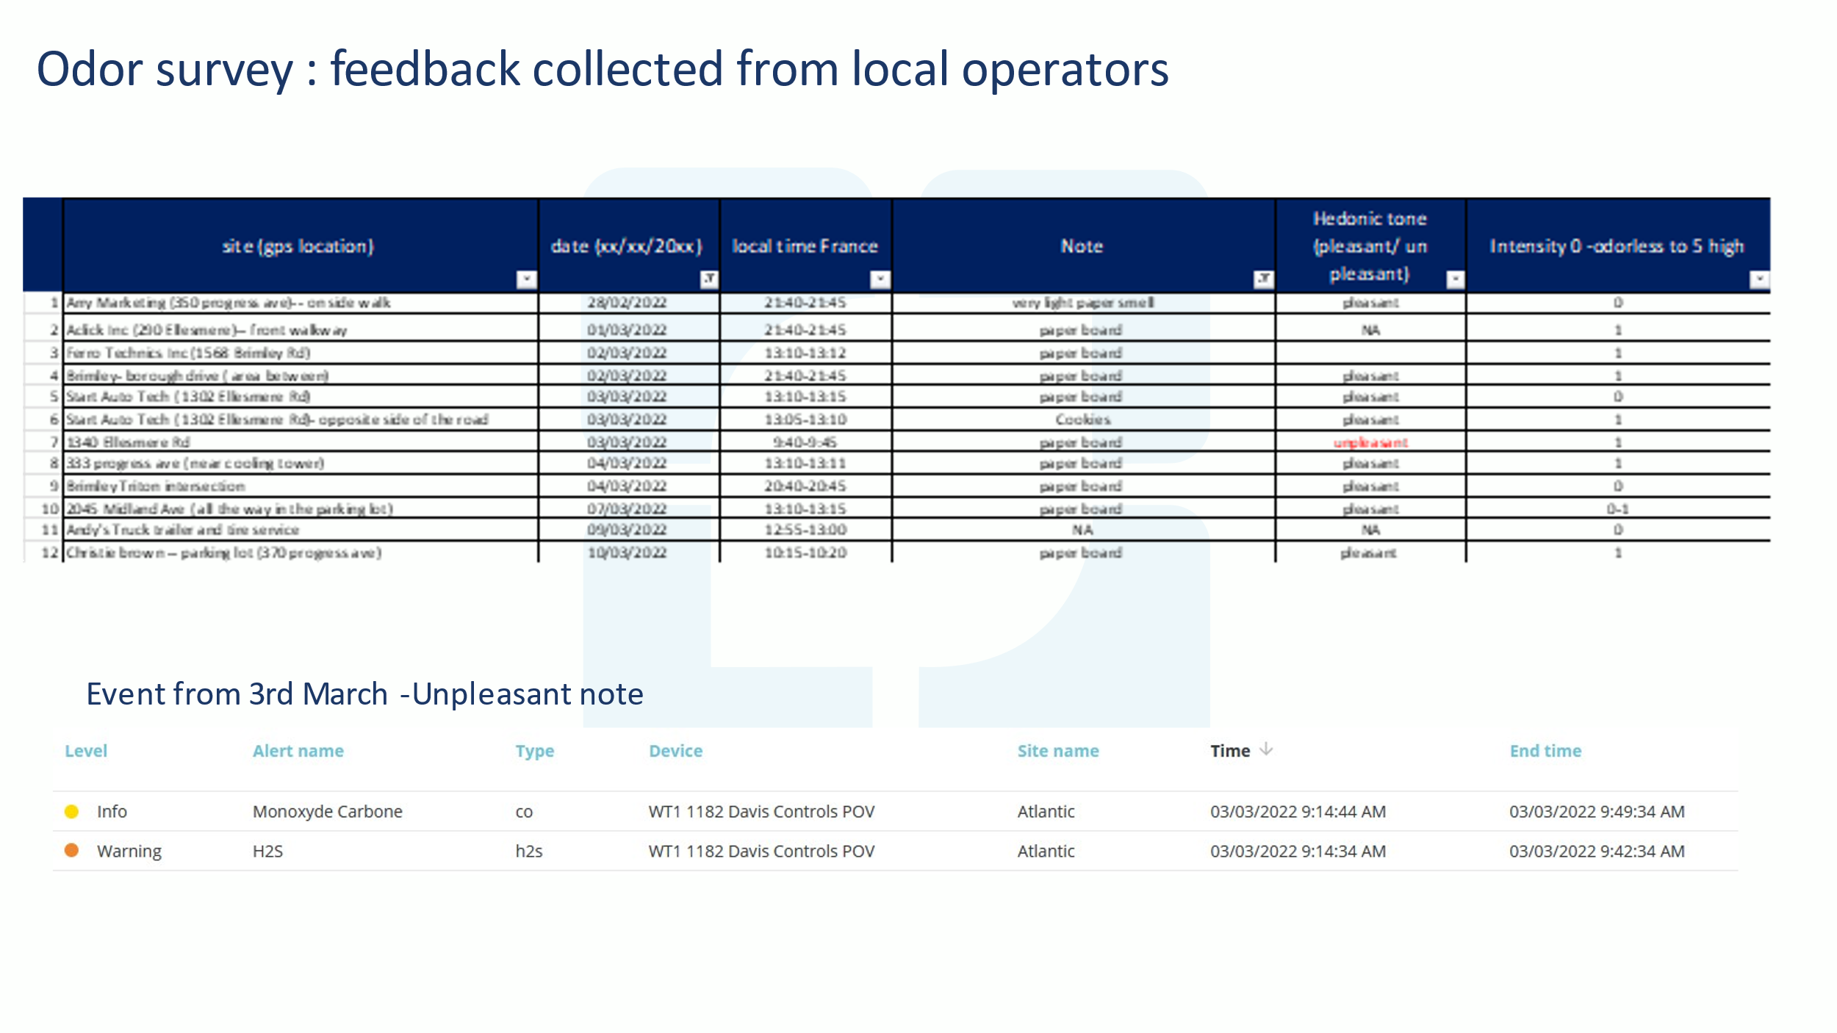

2 – Definition of thresholds, alarms and notifications

Thanks to the sensory panel we have been able to set up some alarms level based on the Ellona OU

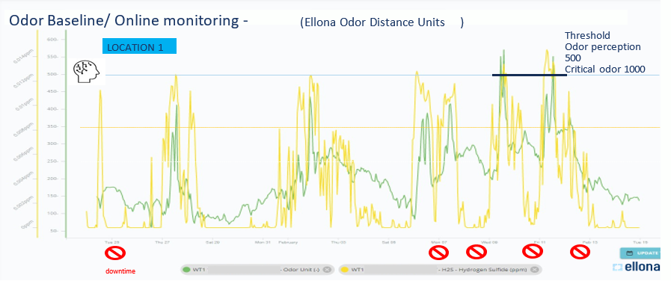

Fig 4 , the green line is the Ellona OU and the Yellow is the level of H2S. It is interesting to notice that it happens that the H2S level can be very low (below human sensory odor threshold ) with a simultaneous high level of VOC / Odor. A first alarm has been set up at 500 Ellona OU and a critical alarm at 1000 Ellona OU.

On fig 5, we can see that the level of Ellona OU is much higher at the second source at the vacuum exhaust

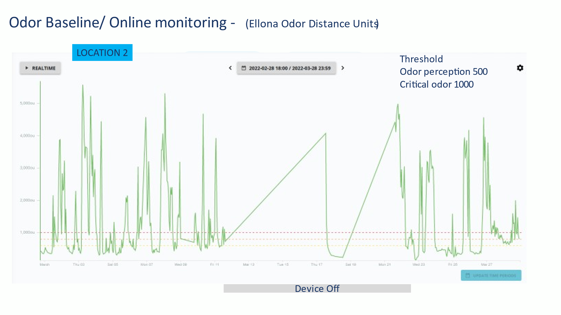

Fig 5 : vacuum exhaust Ellona OU

**3 – Characterization of observed odor level spikes**

An LDA has been built to correlate the MOS and Electrochemical sensors fingerprint with the recording of the sensory panel as described on Fig 6

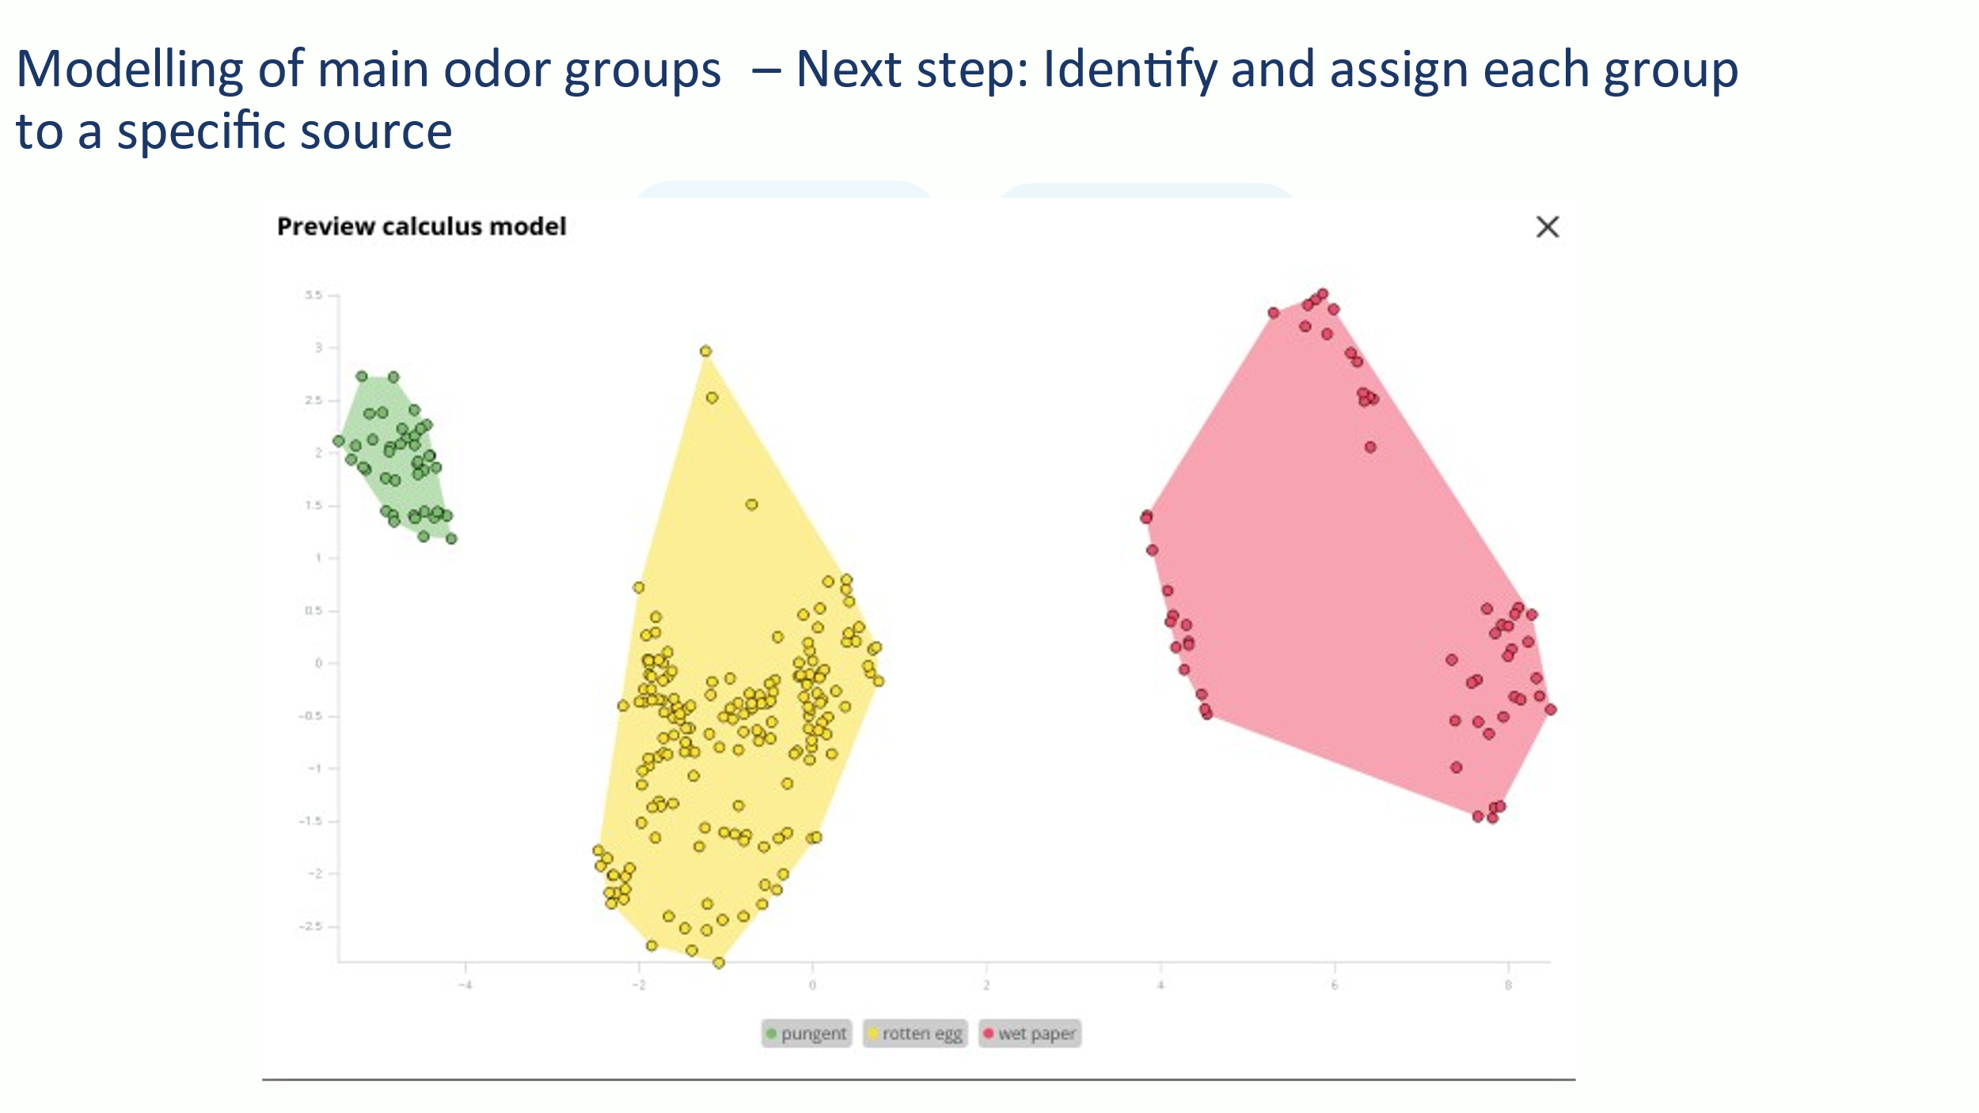

4 – Identification analysis of emitting sources

Then the measurement and projection on the LDA on line is performed as we can see on fig 7

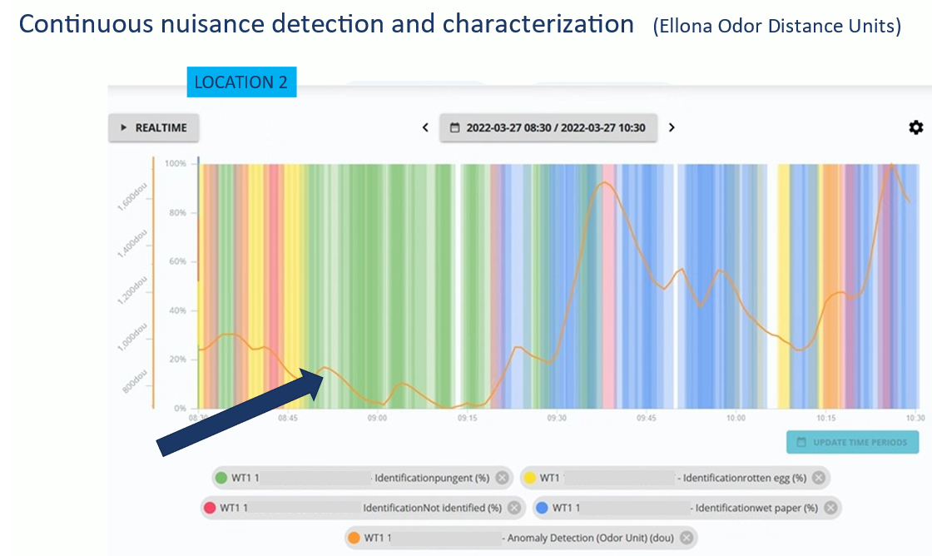

On Fig 7, one can see in orange curve a permanent monitoring of the Ellona OU that is systematically above the 500 OU defined as the first level of Alarm . In color, we can see the identification on line of the various type of smell, including some unknown odor profiles in red ( qualified as cooked ) ; Further investigation are undertaken to identify theses odors as coming either from the cooking company or from the chemical one by performing fence line sampling.

The initial model has been validated by comparing the WT1 odor identity projection and the sensory panel for 2 weeks with an accuracy that was above 80 % , and has allow us to perform Odor correlation analysis with operational activities as well as triggering of alerts and alarms for remediation purposes

During this study , we did realize that

2 – On site observations are very valuable/ needed for the model build up

3 – Different odorous activities are present on the site (some P&P company related – even when the plant was off and therefore linked to a either the food or the industrial companies close by )

4- Different unpleasant odors were identified/ intensity assessed (rotten egg- wet paper- pungent); including duration and persistence

5 – Wet paper Odor is the predominant one.

6 – 82 % of human observations were matched with platform readings

8 – Odor quantification and identification: Model is running and can be used on a continuous basis

9 – With a robust input and source analysis it is possible to identify the sources via a fingerprinting technique

10 – Odor measurements can be currently related to specific operational activities

**Next Steps to connect Monitoring with Operational outcomes**

1 – Finalize the Fingerprinting (more sources’ identification)

2 – Additional devices deployment (covering most relevant sources/ cardinal points)

3 – Weather station info correlation – can be done at the platform

4 - Dispersion analysis – understand critical impact points

5 – further labelling of the Operational activities via the QR code to strengthen the correlation –

6 – Automatic remediation/ actuation (e.g., via 4-20mA connector)

8 – Recurring customized reporting towards the community

CONCLUSION

The WT1 has been shown as being able to

* A tool for mapping and monitoring industrial nuisances related to transit activity and in particular toxic substances (gas, odors, noise, particles...)
* An identification tool (gas, odors, noise and soon particles
* A health and wellness tool for employees and the neighborhood
* A tool to improve citizens' engagement and communication
* A tool for better management of transport activity (optimization of operations, optimization of maintenance operations, optimization of cleaning processes)
* A remediation tool (remediation scrubber management...)